Height – 6’0” REESE WEAVER 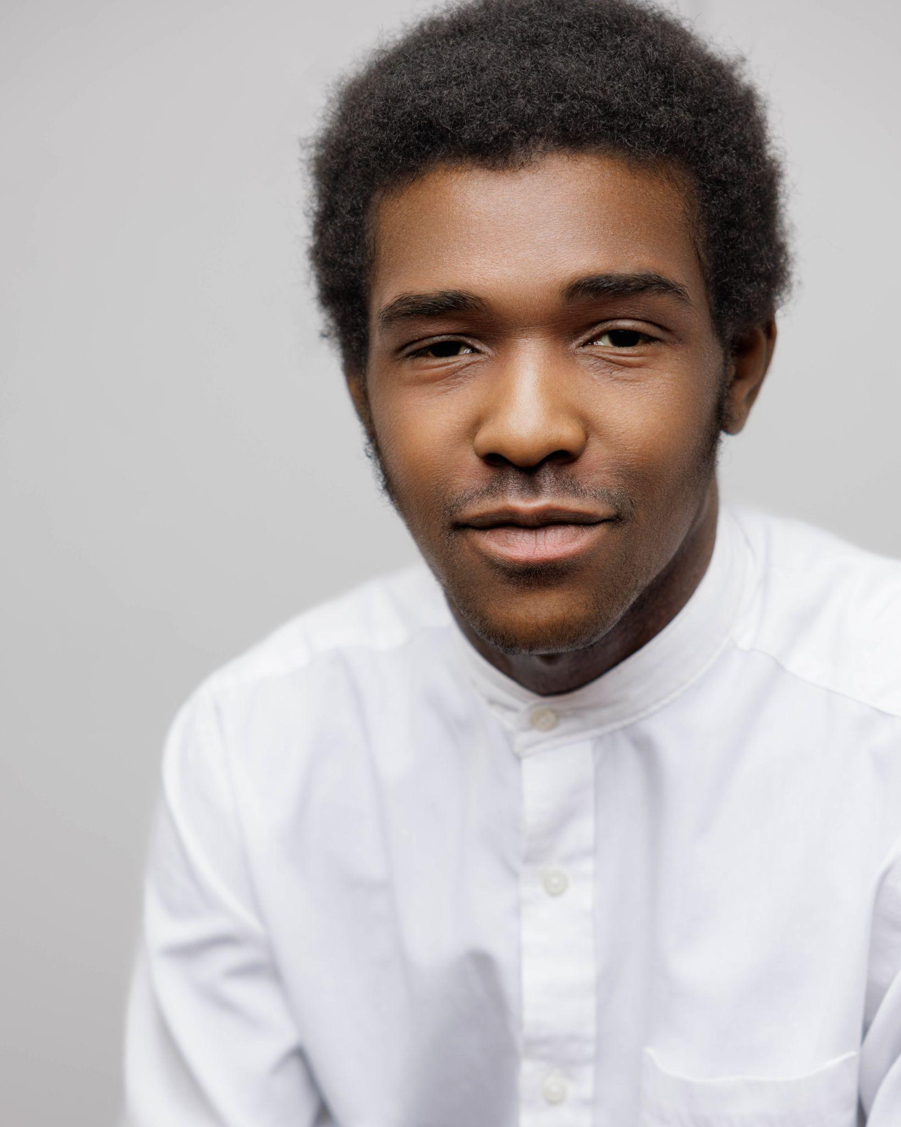
Hair Color – Black Phone: 301-787-3335
Eye Color – Brown E-mail: reese_zero@outlook.com
Vocal Range – Baritone/Tenor

STAGE EXPERIENCE
Pirates of Penzance Police Ensemble BMHS Theatre ‘18
The Enchanted Executioner #1 BMHS Theatre ‘19
Hunchback of Notre Dame Jehan Frollo/Ensemble BMHS Theatre ‘19
Twelfth Night Duke Orsino BMHS Theatre ‘20
Hand To God Jason/Tyrone McDaniel College Theatre ‘21
Sherlock! The Musical Moriarty McDaniel College Theatre ‘22
Wintertime Frank McDaniel College Theatre ‘22
Radium Girls Arthur Roeder McDaniel College Theatre ‘22
Heathers Kurt McDaniel College Theatre ‘23
Urinetown, The Musical Officer Lockstock McDaniel College Theatre ‘23
Eurydice Orpheus McDaniel College Theatre ‘24
The Underpants Benjamin Coehen McDaniel College Theatre ‘24
Gross Indecency Edward Carson/Narrator 5 McDaniel College Theatre ‘24
Measure For Measure The Duke McDaniel College Theatre ‘24
Legally Blonde Chad/Sundeep/Carlos McDaniel College Theatre ‘25

EDUCATION
Bishop McNamara High School: 2017-2021, Graduated with Diploma
McDaniel College: 2021-2025, BA in Theatre Arts

TRAINING
Acting: Gené Fouche (McDaniel), Elizabeth Van Den Berg (McDaniel)
Voice: Kyle Engler (McDaniel)
Dance: Musical Theatre Dance Styles (2 years at McDaniel)

SPECIAL SKILLS
Singing (Baritone/Tenor), Dancing
Guitar (Electric and Acoustic), West African Drumming
Puppetry

